**BATCH BSAI**

**NAME : ABDULLAH  
ROLL NO : 2430 – 0067**

**TASK 1** : Make a document for a short story using pictures and little descriptions that explain the picture. Use 7-10 pictures minimum & give a suitable title to the story.

**Thirsty Crow**

A crow looking around in a dry, hot environment, appearing thirsty. On a scorching day, a thirsty crow searches for water but finds none.

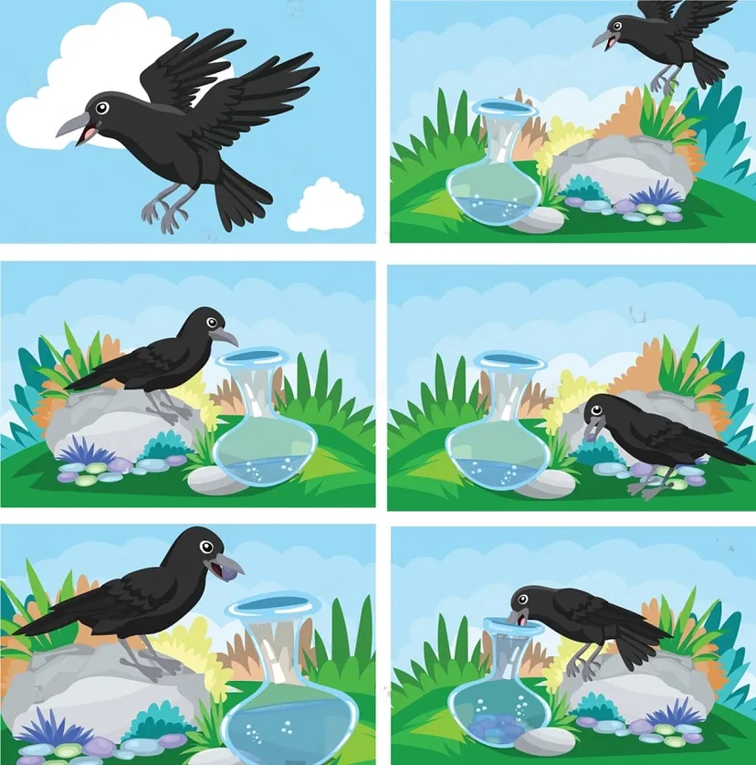

The crow spotting a pot in the distance. After a long search, the crow finally sees a pot that might contain water.

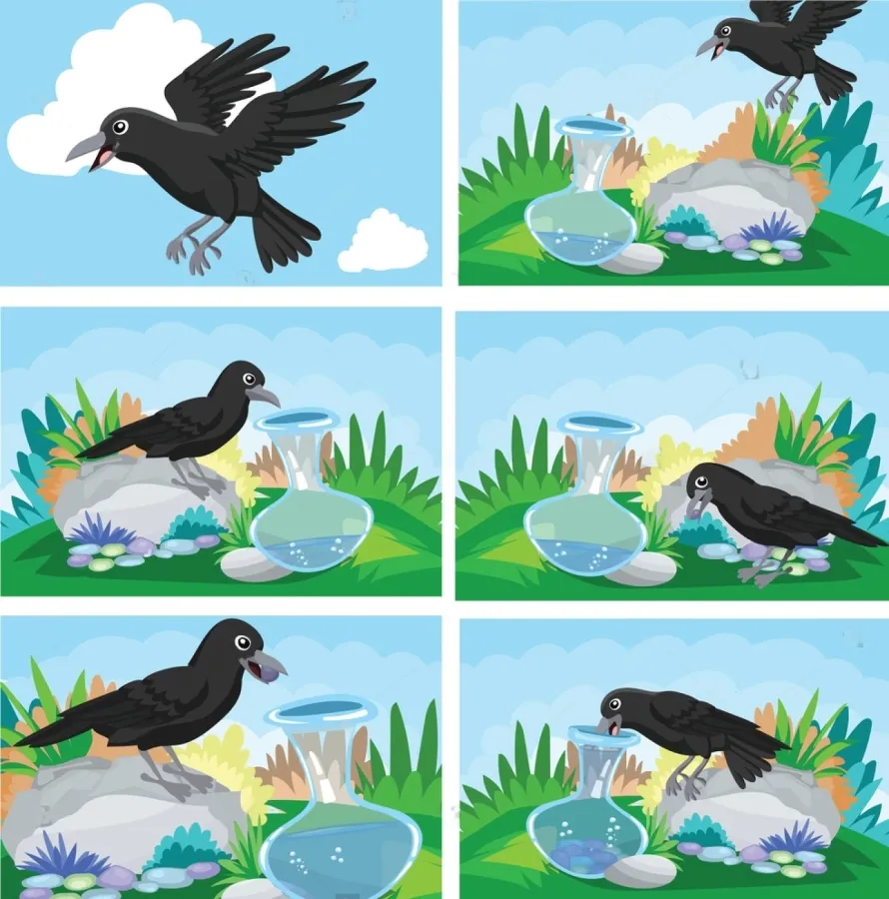

The crow flies down, but discovers that the water level is too low for him to reach. The crow thinking, with small pebbles scattered around.



The clever crow thinks of a solution. He notices some pebbles nearby. The crow picking up a pebble with its beak and dropping it into the pot.



One by one, the crow picks up pebbles and drops them into the pot. The water level gradually rising as pebbles accumulate at the bottom. With each pebble, the water level rises slowly. The crow happily drinking the water from the now reachable level.



With each pebble, the water level rises slowly. The crow happily drinking the water from the now reachable level.



Finally, the water is high enough, and the crow quenches his thirst. The crow flying away, looking satisfied an Happy .



**Title :** By thinking and working hard, we may find the solution to any difficult problem.